**Lesson 16: Perimeter and Area of Quadrilaterals**

**Do Now:**

**Estimate the area and perimeter of the following figures.**

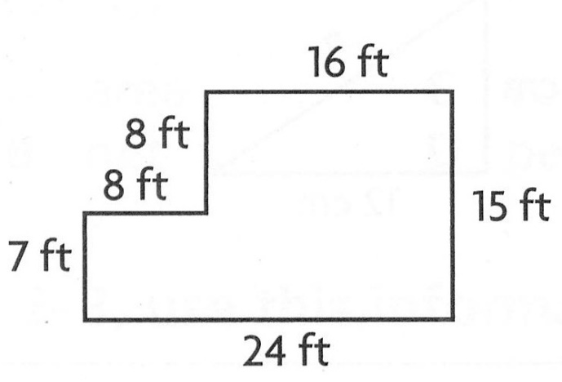

32 inches

about 30 in2 78 feet

296 feet2

Perimeter = 30 grids

Area = 22 grids

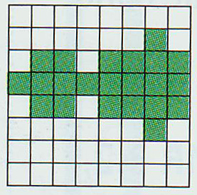

**Independent Practice:**

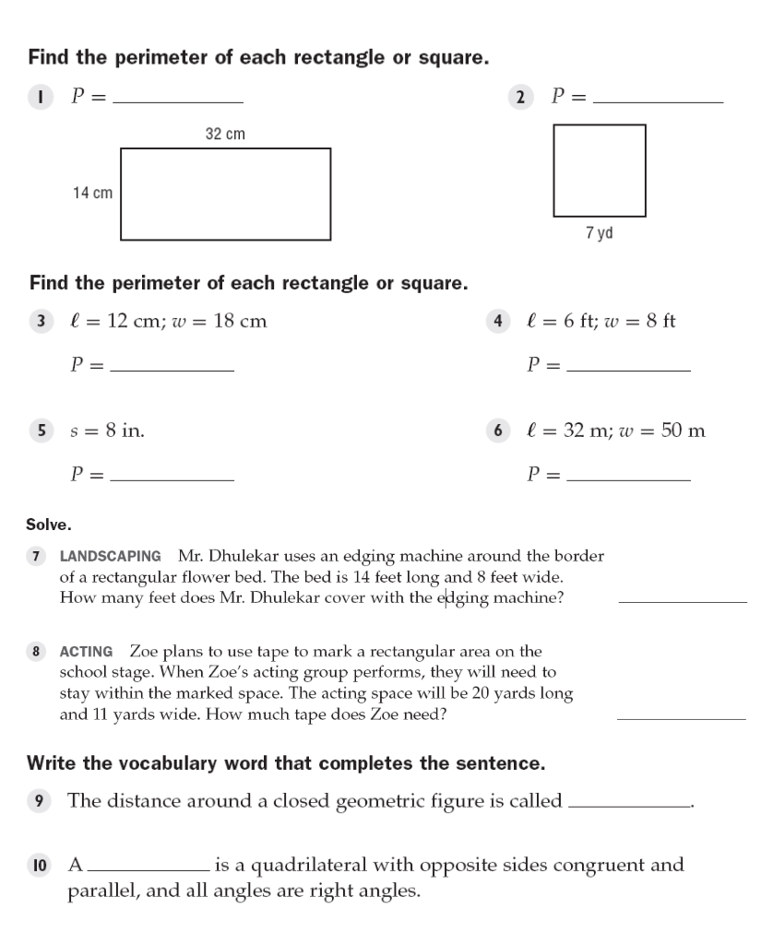

92 cm 28 yd

60 cm; A = 216 cm2 28 ft; A = 48 ft2

32 in; A = 64 in2 164 m; A = 1600 m2

112 ft2

62 yards

perimeter

square

**Closure:**

160 ft2

C

200 ft2

D

320 ft2

1040 ft2

